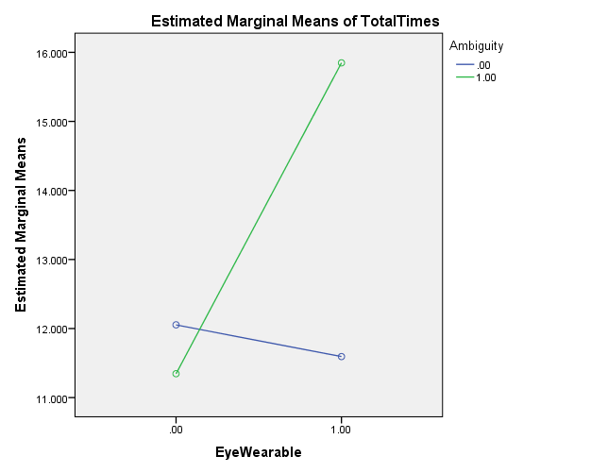

|  |  |  |  |  |  |
| --- | --- | --- | --- | --- | --- |
| **Tests of Between-Subjects Effects** | | | | | |
| Dependent Variable: TotalTimes | | | | | |
| Source | Type III Sum of Squares | df | Mean Square | F | Sig. |
| Corrected Model | 1242.818a | 3 | 414.273 | 2.709 | .045 |
| Intercept | 54697.600 | 1 | 54697.600 | 357.735 | .000 |
| EyeWearable | 345.876 | 1 | 345.876 | 2.262 | .133 |
| Ambiguity | 266.058 | 1 | 266.058 | 1.740 | .188 |
| EyeWearable * Ambiguity | 520.690 | 1 | 520.690 | 3.405 | .066 |
| Error | 79813.738 | 522 | 152.900 |  |  |
| Total | 161697.599 | 526 |  |  |  |
| Corrected Total | 81056.555 | 525 |  |  |  |
| a. R Squared = .015 (Adjusted R Squared = .010) | | | | | |